| **EXP:7**  **10/04/2025** | **Implement program for decomposing time series data into trend and seasonality** |
| --- | --- |

**AIM:**

To analyze the car sales time series data using additive and multiplicative decomposition methods, in order to identify and visualize the underlying trend, seasonality, and residual components.

**PROCEDURE:**

**1) Import Necessary Libraries**

import pandas as pd

import matplotlib.pyplot as plt

from statsmodels.tsa.seasonal import seasonal_decompose

**2)** **Load and Inspect the Dataset**

**df = pd.read_csv("/content/sample_data/Car_sales.csv")**

**3) Convert Date Column and Set Index**

df['Latest_Launch'] = pd.to_datetime(df['Latest_Launch'], errors='coerce', infer_datetime_format=True)

df = df.dropna(subset=['Latest_Launch'])

**4)Perform Additive Decomposition (6-Month Period)**

sales_ts = df.groupby('Latest_Launch')['Sales_in_thousands'].sum().sort_index()

**5)Resample to monthly data**

sales_ts = sales_ts.resample('M').sum().fillna(0)

**6) Decompose with a seasonal period**

decomposition = seasonal_decompose(sales_ts, model='additive', period=6)

### **7) Shift series to make all values positive**

shifted_ts = sales_ts + 1)

**8)Multiplicative decomposition**

multiplicative_decomp = seasonal_decompose(shifted_ts, model='multiplicative', period=6)

fig2 = multiplicative_decomp.plot()

fig2.set_size_inches(12, 10)

plt.suptitle("Multiplicative Decomposition (Shifted Series)", fontsize=18, y=1.02)

plt.tight_layout(rect=[0, 0.03, 1, 0.95])

plt.show()

**OUTPUT:**

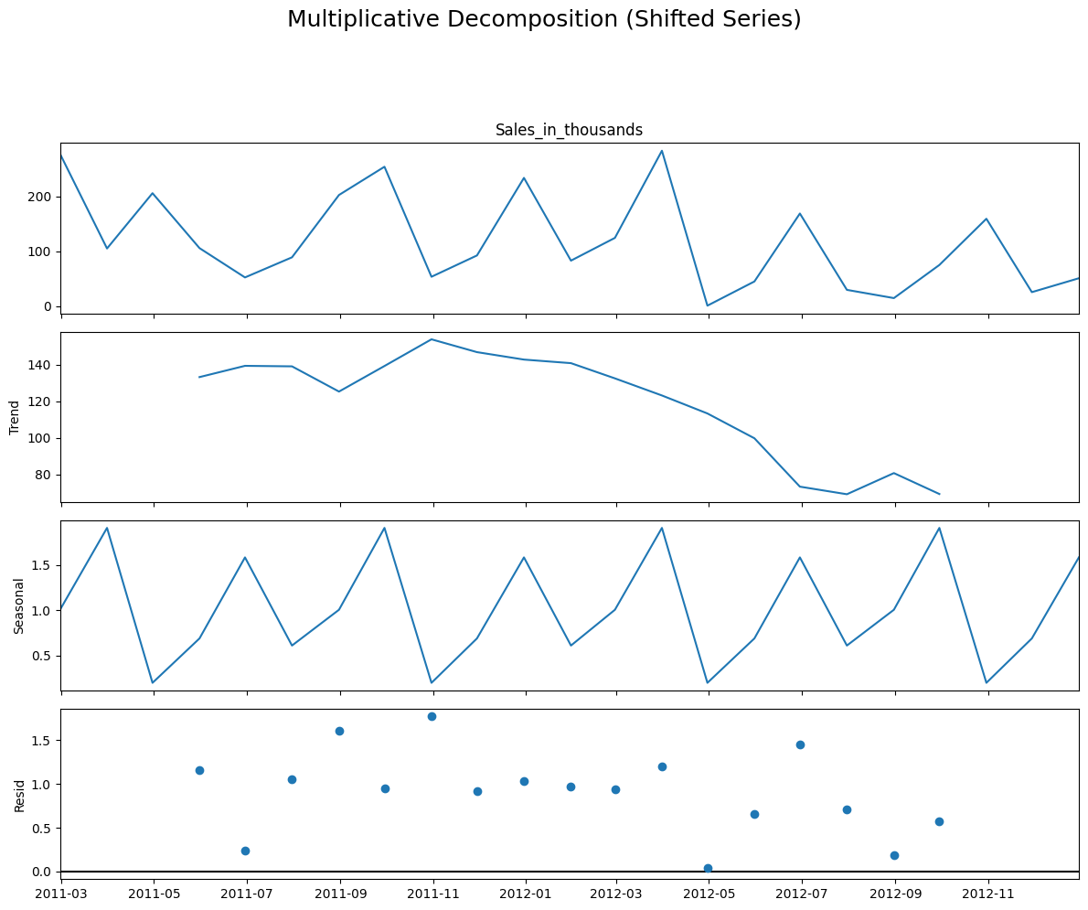

**RESULT:**

Thus the program has been executed successfully